**12. Design, develop, code and run the program in any suitable language to implement an absolute letter grading procedure, making suitable assumptions. Determine the basis paths and using them derive different test cases, execute these test cases and discuss the test results.**

1. #include<stdio.h>
2. main()
3. {
4. float avmar;
5. printf("Enter the average marks of the student\n");
6. scanf(“%f”, &avmar);
7. printf("The average marks are=%f\n", avmar);
8. if((avmar<35)&&(avmar>0))
9. printf("fail");
10. else if((avmar<=40)&&(avmar>35))
11. printf("Grade C");
12. else if((avmar<=50)&&(avmar>40))
13. printf("Grade C+");
14. else if((avmar<=60)&&(avmar>50))
15. printf("Grade B");
16. else if((avmar<=70)&&(avmar>60))
17. printf("Grade B+");
18. else if((avmar<=80)&&(avmar>70))
19. printf("Grade A");
20. else if((avmar<=100)&&(avmar>80))
21. printf("Grade A+");
22. else printf(''Invalid input\n”);
23. }

**Test case Name: Basis path testing**

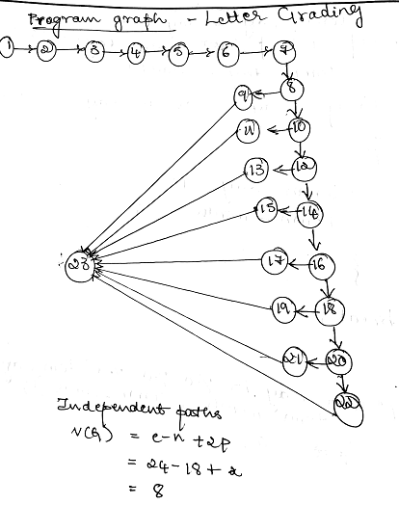

|  |  |
| --- | --- |
| Nodes in program graph | Nodes in DD path graph |
| 1-7 | A |
| 8 | B |
| 9 | C |
| 10 | D |
| 11 | E |
| 12 | F |
| 13 | G |
| 14 | H |
| 15 | I |
| 16 | J |
| 17 | K |
| 18 | L |
| 19 | M |
| 20 | N |
| 21 | O |
| 22 | P |
| 23 | Last |

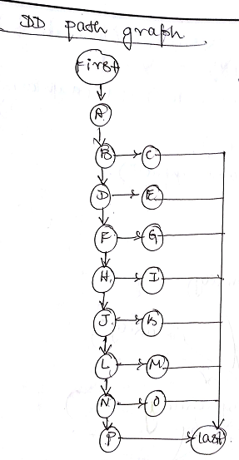

**CYCLOMATIC COMPLEXITY:**

**V(G) = e - n +2p**

**= 23-17+2**

**V(G)=8**

**According to cyclomatic complexity we can derive 8 independent(basis) paths**

**Consider the below path P1 as baseline path and flip this path at every predicate node to get remaining basis paths**

**P1: A, B, D, F, H, J, L, N, P, Last**

**TEST CASES:**

|  |  |  |  |  |  |  |
| --- | --- | --- | --- | --- | --- | --- |
| **TC ID** | **Test Description** | **Input** | **Expected Output** | **Actual Output** | **Status** | **Remarks** |
| 1 | P1: A, B, D, F, H, J, L, N, P, Last | 110 | Invalid input | Invalid input | Test Pass | Baseline path |
| 2 | P2: A, B, C, Last | 30 | Fail | Fail | Test Pass | Flip at B |
| 3 | P3: A, B, D, E, Last | 37 | Grade C | Grade C | Test Pass | Flip at D |
| 4 | P4:A, B, D, F, G, Last | 45 | Grade C+ | Grade C+ | Test Pass | Flip at F |
| 5 | P5:A, B, D, F, H,I, Last | 55 | Grade B | Grade B | Test Pass | Flip at H |
| 6 | P6:A,B,D, F, H, J, K, Last | 65 | Grade B+ | Grade B+ | Test Pass | Flip at J |
| 7 | P7:A, B, D, F, H, J, L, M, Last | 75 | Grade A | Grade A | Test Pass | Flip at L |
| 8 | P8: P7:A, B, D, F, H, J, L, N, O, Last | 90 | Grade A+ | Grade A+ | Test Pass | Flip at N |